Klaros 4.5.0
Preparation: Test cases are imported by Excel.

- TC00013 and TC00014 are both in P00004 project.
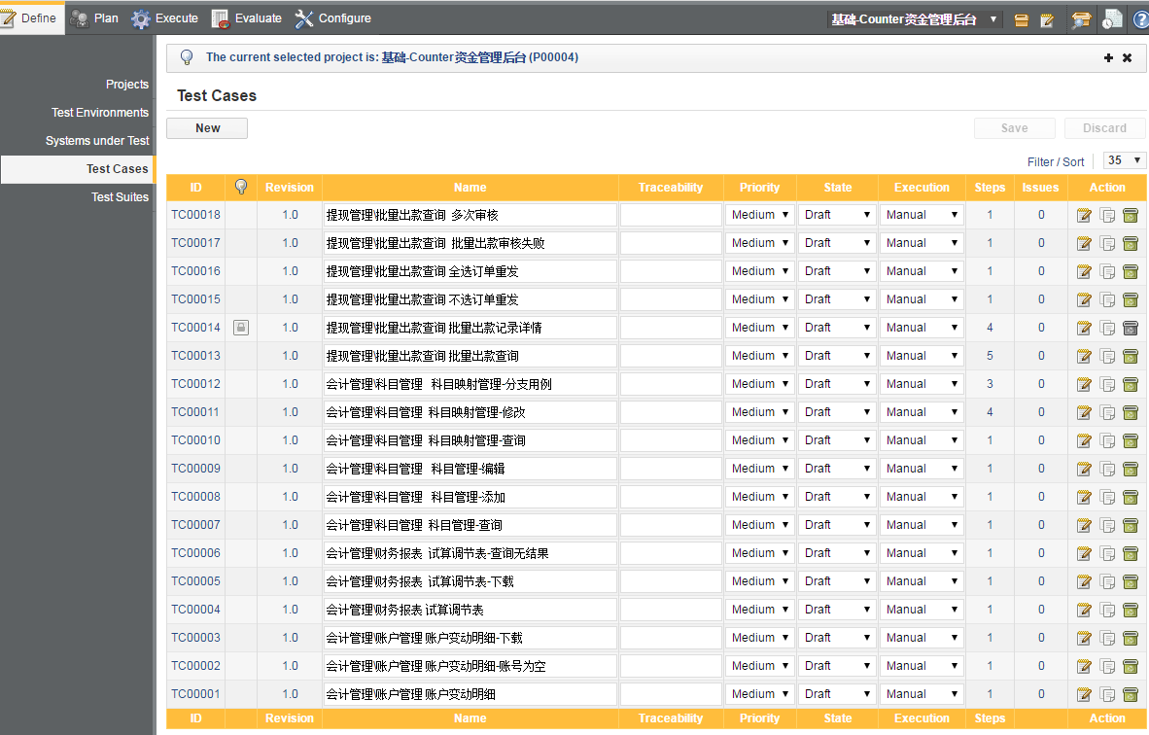

- The first step of TC00013 is:
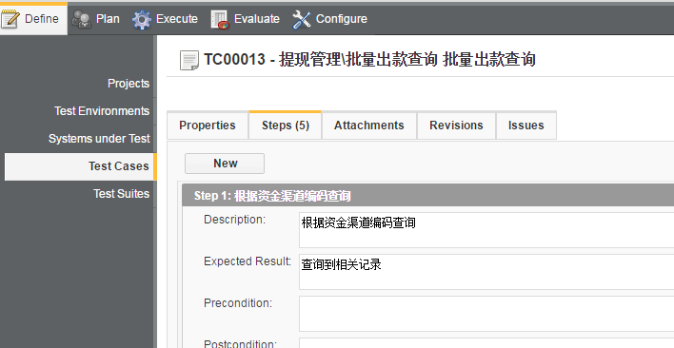

- The first step of TC00014 is:
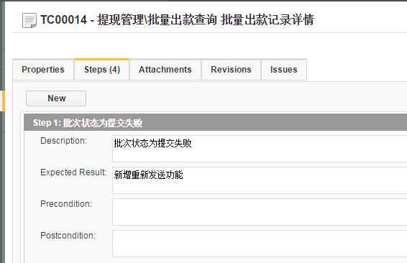

- When I execute the TC00013, the first step is wrong in the execution box. The action and expected result should be the step of TC00014’s.
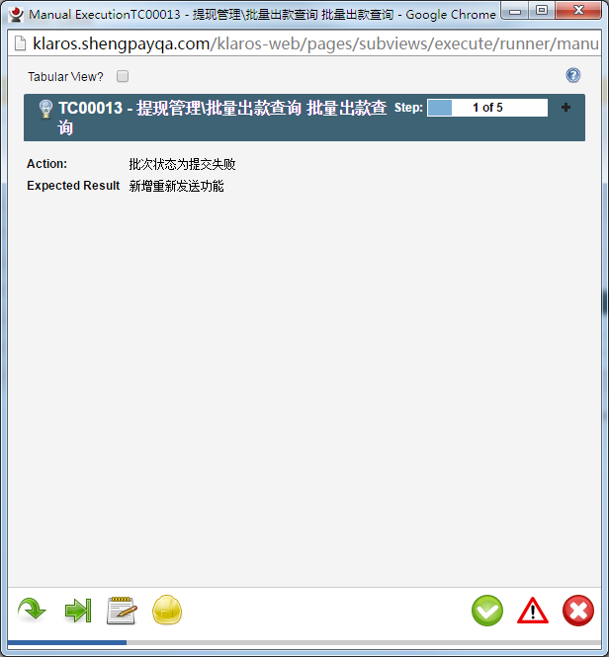

- Step1 of TC00013 in database:

SELECT * FROM K_TC_STEP WHERE ACTION = '根据资金渠道编码查询'
Get the step KL__ID = de26700e-297b-4be3-b735-090650b40bba

SELECT * FROM K_REL_TC_FRAG WHERE FRAGMENT = 'de26700e-297b-4be3-b735-090650b40bba'

FRAGMENT TESTCASE ID
de26700e-297b-4be3-b735-090650b40bba 0a086b52-dbfb-4d84-935e-5ef888f169c3 0

Get the TESTCASEID: 0a086b52-dbfb-4d84-935e-5ef888f169c3

Check the test case:

SELECT KL__ID,NAME FROM K_TEST_CASE WHERE KL__ID = '0a086b52-dbfb-4d84-935e-5ef888f169c3'

KL__ID name
0a086b52-dbfb-4d84-935e-5ef888f169c3 TC00013

The data should be ok.

- Step1 of TC00014 in database:
SELECT KL__ID FROM K_TC_STEP WHERE ACTION = '批次状态为提交失败'

Get the step KL__ID = f1158077-87bf-4dc5-a5a3-e7d3de3bcd86

SELECT * FROM K_REL_TC_FRAG WHERE FRAGMENT = 'f1158077-87bf-4dc5-a5a3-e7d3de3bcd86'

FRAGMENT TESTCASE ID
f1158077-87bf-4dc5-a5a3-e7d3de3bcd86 3db30f23-973f-4513-870e-d270954d5b42 0

get the TESTCASE = 3db30f23-973f-4513-870e-d270954d5b42

SELECT KL__ID,NAME FROM K_TEST_CASE WHERE KL__ID = '3db30f23-973f-4513-870e-d270954d5b42'
KL__ID NAME
3db30f23-973f-4513-870e-d270954d5b42 TC00014

The step data should also be ok for TC00014.

