Click on Issues
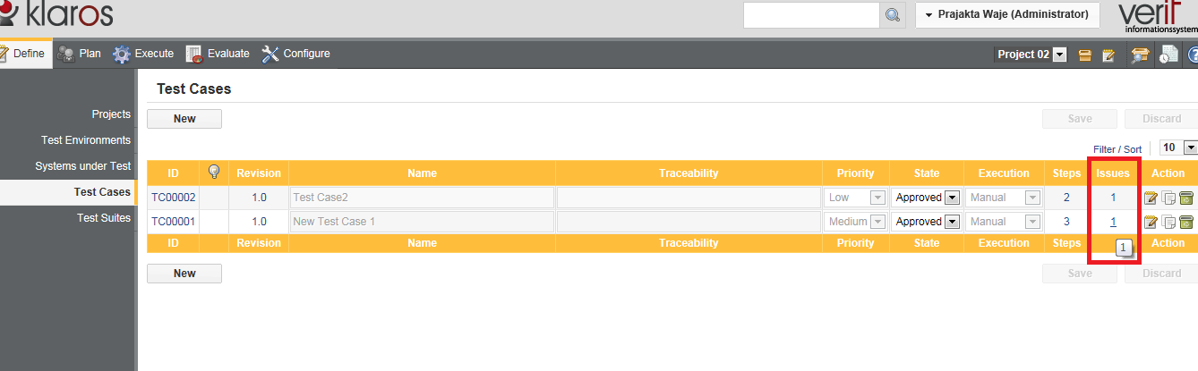

Page redirected to edit test case
